CAPSTONE TWO - Project Proposal

**🛝Playdate Buddy🧸**

**Introduction:**

As a parent of a toddler I know that it can be hard to know where to take your child to play and hard to meet other parents who have children of a similar age to help your children learn how to play with others. This website (possibly stretching to include a mobile app version) will aim to tackle the goal of finding suitable playdate venues/activities for parents of young children and/or schedule events with other users who also have young children. The target demographic for the app would likely be 20-50 year olds, who are possibly primarily women but not exclusively. Users would have children aged 1-10 as older children would likely not want to be at a playdate with their parents or arranged by them.

**Tech Stack:**

* React
* Node.js
* Redux?

The split of the site will likely be fairly even and encompass a full-stack application. The front-end will be heavy with lots of forms, search tools, and components to render. The back-end side of things houses a database to store user data and the use of APIs to retrieve data related to location/places and calendar events/scheduling plus potentially needing to create an API for accessing user data from the database.

**Data Requirements/API Information:**

For the base app there will be two main types of data required: user data and maps/places data.

The user data will be collected through a signup process where the user completes a form to provide the necessary (and optional) information. The data that will be collected is:

* Username
* First name
* Last name
* Email
* Password
* Date of birth
* Child(ren)’s age(s) (gender? Unsure if this is necessary)
* City, Country to provide a general location
* Activities your family enjoys (from a select menu based on API type search options that would be suitable/relevant)?

The maps/places data will be collected through the Google Maps API. The data that will be collected is:

* Map for a user’s specified location
* Places info based off of text specific search or based off of type of activity search

**Proposed Database Schema:**

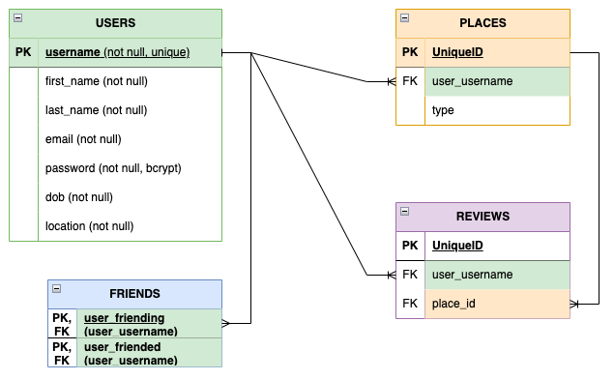

**Potential Issues/Things to Consider:**

* Google Maps API is not familiar and a different format than APIs I am used to working with.
* Would like to include a calendar feature but am not sure if I can find a suitable API for this.
* API quotas for free access - trying to limit unnecessary calls.
* Need to build an API for user features?
* Deciding on the structure/hierarchy for React Components and the potential inclusion of Redux.
* Forcing myself to potentially limit features to make it more achievable.
* Passwords will need to be secured using bcrypt for users signing up and logging in.
* Including and using the suggested favourite activities options.

**Functionality/User Flow/ Features:**

(highlighted features go beyond simple CRUD and/or are stretch goals)

1. Homepage - introduce app with a short description, show login and signup buttons for logged out users.
2. Registration Form page - collect data for USERS table and store in database. Redirect the user to the search page.
3. Login Form page - returning users can login by using their username and password. Check provided data against the database to ensure a valid user before redirecting to the search page.
4. Search Homepage - logged in users are given two search options outlined on the search homepage. They can either search for other users in their location (city, country) or they can search for places.
5. Users Search Page - search database for users with children of a similar age and/or based on favourite activities. Users can friend other users, private message?
6. Places Search Page - a user can choose to show their “home” map based on the location in the USERS table or a different location. They can search by text or by type based on the Google Maps Places API list of types which suitable options will be turned into a select menu list. Users are given the option to save places, which will be saved to the database with their username, and/or to review places, this info will also be saved to the database with their username. Markers added to maps based on stored places from the database?
7. My Map/Places page - a user can view their “home” map based on the location in the USERS table with their saved place markers(?).
8. My Friends page - users can view their friends list with the option to message people from this page.
9. My Playdates page - users can view their scheduled playdates on this page - including users who are attending/invited, the location, date and time. Clicking on the location can bring up the map with a marker for that given location.

Other options to possibly include:

* Groups functionality - users can join a group or set up a group (private/public?)
* Calendar API to track scheduled playdates and availability etc. ?
* Use of the Google Maps Routes API functionality so users can get the route directions for getting to the chosen place location.